Troubleshooting Tools

1. Checking IPv4 Address and Default Gateway :
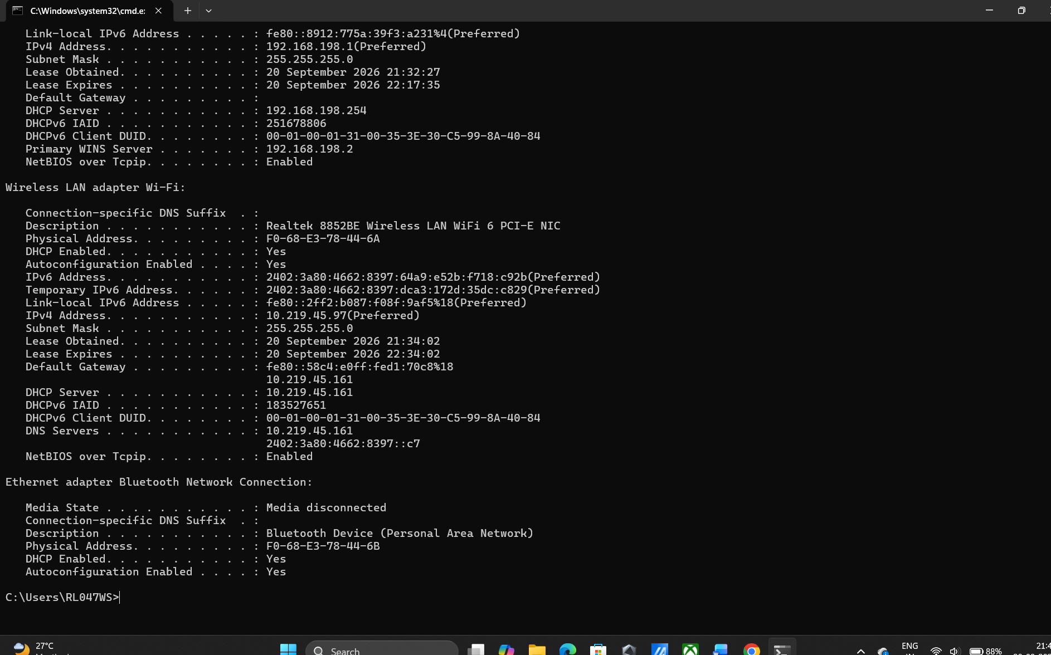

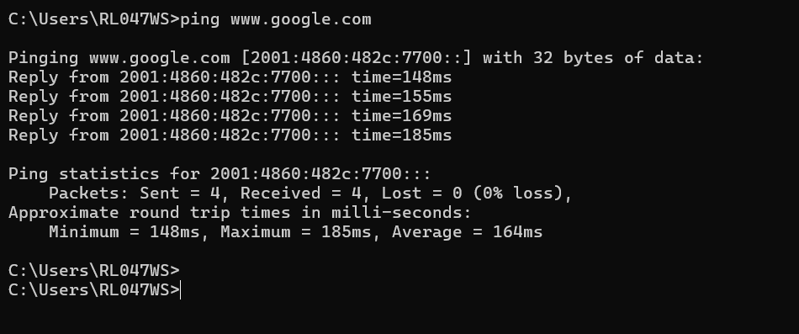
2. Using Ping Command :

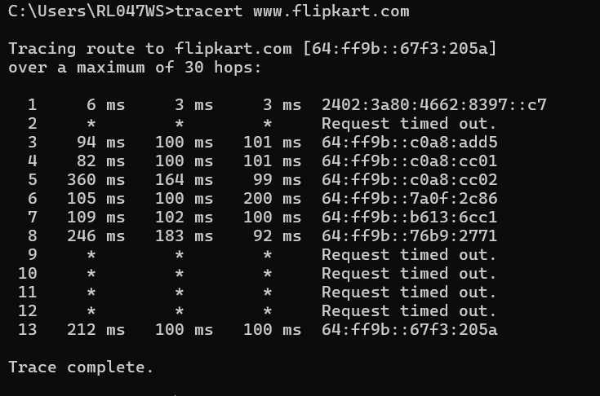
3. Tracert command :
4. Run the nslookup command :
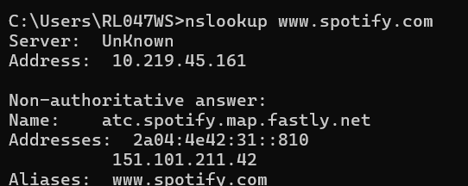

Purpose: This tool helps verify if proper DNS resolution is occurring by querying DNS servers to convert human-readable domain names into IP addresses.

5. Troubleshooting Command :

1.Check Local Network & Gateway:ipconfig.
Verify that your laptop has a valid IP address assigned and is connected to a local network router gateway.
- Verification: Run ipconfig and ensure the IPv4 Address and Default Gateway are not blank and do not start with 169.254.x.x (Auto-IP failure).
2.Check DNS Resolution:nslookup zomato.com.
Verify whether domain names are correctly translating to an IP address or if the issue is a DNS lookup failure.
- Verification: Run nslookup zomato.com. If it returns a valid IP address, DNS is working; if it times out or throws Name Not Found, DNS is broken.
3.Check Network Reachability & Routing:ping zomato.com (or tracert zomato.com).
Verify whether network packets are successfully reaching Zomato's servers or where along the network path packets are being dropped.
- Verification: Run ping zomato.com (or tracert zomato.com). Receiving replies confirms end-to-end connectivity; timing out indicates a network path failure, block, or firewall rule.

